F - C A P C H I N E S E C U R R I C U L U M C O U N C I L

DEVELOPING CHINESE – Level 2
UNIT 2: Assessment: Interpretive Reading

Learning Targets

- I can ask and answer simple questions about weather and climate.
- I can discuss schedules and routines sequentially.
- I can speak with another person about school schedules.

Scenario 1

Please read this weather report chart
and answer questions:

- 上海的天气怎么样？
- 上海星期三白天是多少度？
- 上海星期四夜间是多少度？
- 你喜欢上海的天气吗？为什么？

Scenario 2 Read the email and answer the questions:

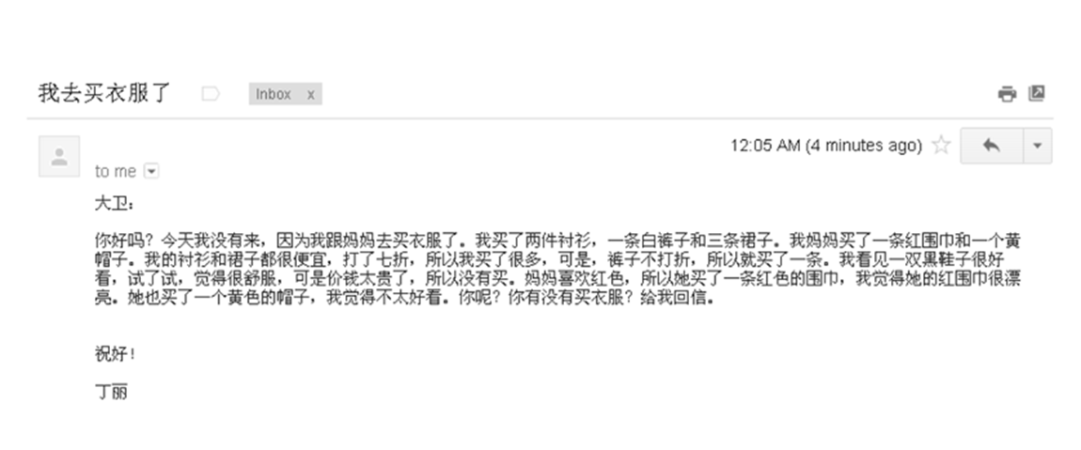

1. 丁丽买了几件上衣？

2. 丁丽买的裤子是什么颜色的？

3. 丁丽为什么(why)买了很多衬衫和裙子？

4. 丁丽为什么买了一条裤子？

5. 丁丽说她很喜欢一双黑鞋子，可是为什么没有买？

6. 丁丽的妈妈为什么买了一条红围巾？

Adapted from Jefferson County Public Schools, KY, 2011

